ENCODER CAN (CEDS) 2019-1-02

From CAN_A.c (line 20)

// CAN_A Int Base = 127 Car Top CAN
// CAN_B Int Base = 157 CAN Open Encoder
// CAN_C Int Base = 178 Group CAN
// CAN_D Int Base = 199 Mechine Room CAN

From Main.c (line 293)

/*Init CAN MR */
Init_CanA_bus();

=============================
F:\repos\MOVFR_0075\movfr_0075 tester.c:2767: FireOutPut(Brd1, sebCLOSE);
F:\repos\MOVFR_0075\movfr_0075 tester.c:2978: FireOutPut(Brd1, sebCLOSE);
F:\repos\MOVFR_0075\movfr_0075 tester.c:3138: FireOutPut(Brd1, sebOPEN);
F:\repos\MOVFR_0075\movfr_0075 tester.c:3595: FireOutPut(Brd1, sebCLOSE);

====== USING PCAN WITH CEDS ========

CEDS baud rate is 250 kb (normally, GAL CAN baud is 115.2 kb).
Start a new project:
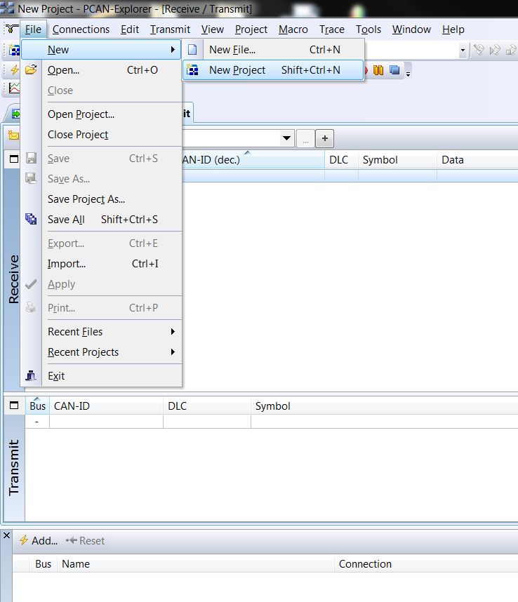
To set PCAN to 250 kb, start a new project. Name project ‘CEDS_2_CAN’.
On top menu ribbon, select ‘Tools / Nets Configuration’.
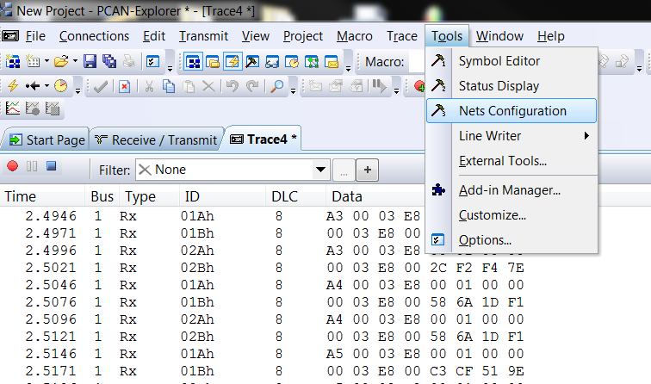
Which will bring up:
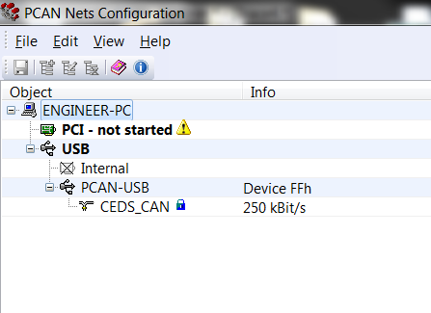
Double-click on “CEDS_CAN” to get to window for defining baud. Name project ‘CEDS_2_CAN’ and select 250 kBit/s.
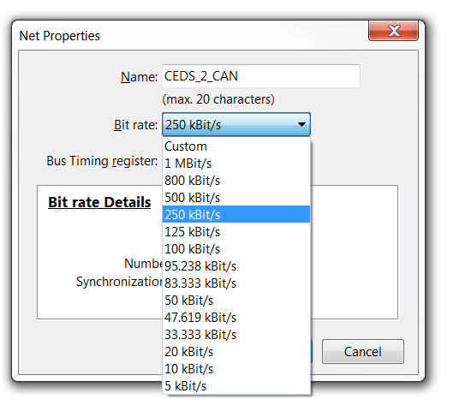
End result should be:
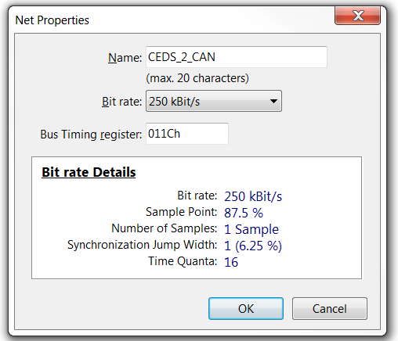
Click ‘OK’ and then Save “Ctrl/S’. Exit the PCAN nets Configuration.
In ‘Connections’ window,
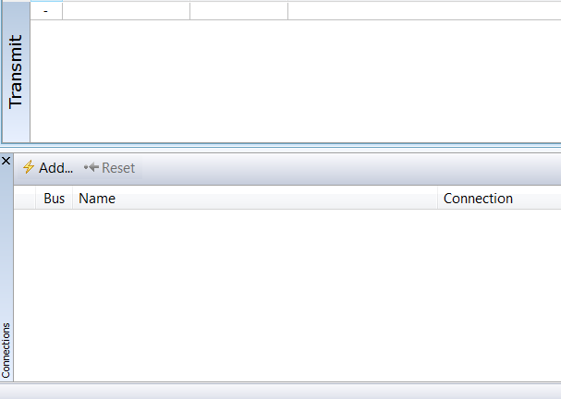
Click ‘Add…’ and select ‘CEDS_2_CAN’.
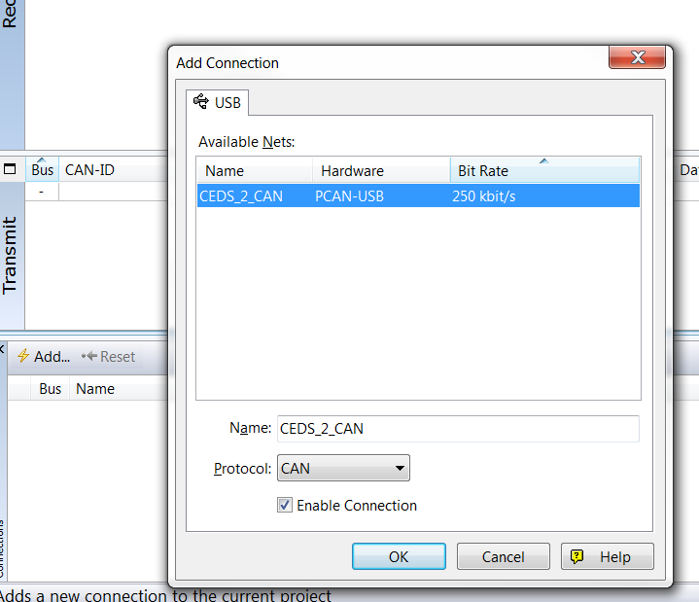

And click OK.
Now, click “Start new Tracer”:
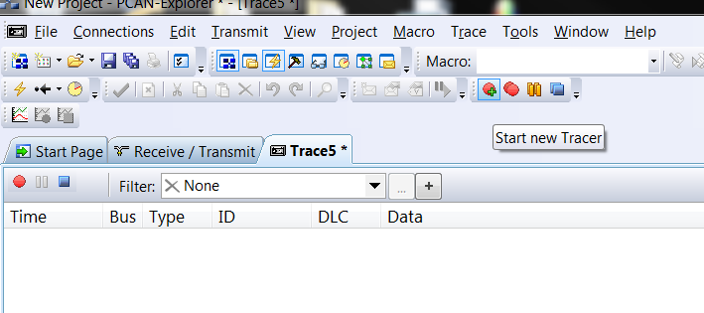

Turn on Selector 6 board (GALX-1133) and see CEDS CAN data in ‘Receive/Transmit’ window and ‘Tracex’ window.
